Dear Parents and Carers,

Please do not bring the following foods to nursery:
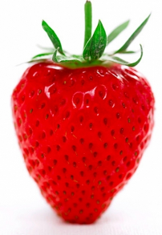Strawberries 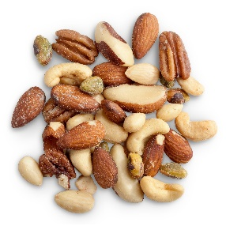Nuts Eggs

There are children at nursery who could become very poorly if they have any contact with these foods.
Thank you

